Lab: Securing a Hadoop Cluster

Objective: | To understand how to configure security for HDP.
Successful Outcome: | The hadoop user will be authenticated and authorized to view the contents of the /user folder in HDFS.
Before You Begin: | SSH into hadoop-master.

- Create a New User
  - On hadoop-slave1 as root, create a new user named hadoop:
# useradd -g hadoop hadoop
  - Switch to the hdfs user and create a new directory in HDFS named /user/hadoop.
  - Change ownership of /user/hadoop in HDFS to the hadoop user.
  - Exit out from the hdfs user, and switch to the hadoop user.
  - Check whether you can do a listing of the /user directory successfully:
$ hadoop fs -ls /user
  - Exit out from the hadoop user.
NOTE: The current cluster is not a secure cluster so you can easily do a listing of the /user directory in HDFS successfully.
- Install Kerberos
  - As the root user on hadoop-slave1, install the following packages:
# yum -y install krb5-server krb5-libs krb5-auth-dialog krb5-workstation
  - Login to hadoop-slave2, hadoop-slave3 and hadoop-slave4 and install the Kerberos client only:
# yum -y install krb5-workstation
- Configure Kerberos
  - On hadoop-slave1, edit the configuration file /etc/krb5.conf and modify the value for kdc and admin_server to hadoop-slave1:
# vi /etc/krb5.conf

[realms]
EXAMPLE.COM = {
kdc = hadoop-slave1
admin_server = hadoop-slave1
}
  - Copy the /etc/krb5.conf file to all the other nodes:
# ~/scripts/distFile.sh /etc/krb5.conf /etc/krb5.conf
  - Enter the following command to create a Kerberos database using the kdb5_util utility:
# kdb5_util create -s
During this step it will ask you to define a master key. Enter 1234 as the key.
- Start Kerberos
  - Start the KDC server by executing following commands:
# /etc/rc.d/init.d/krb5kdc start
# /etc/rc.d/init.d/kadmin start
- Run the Enable Security Wizard
  - In Ambari, go the Admin page and click on the Security link:
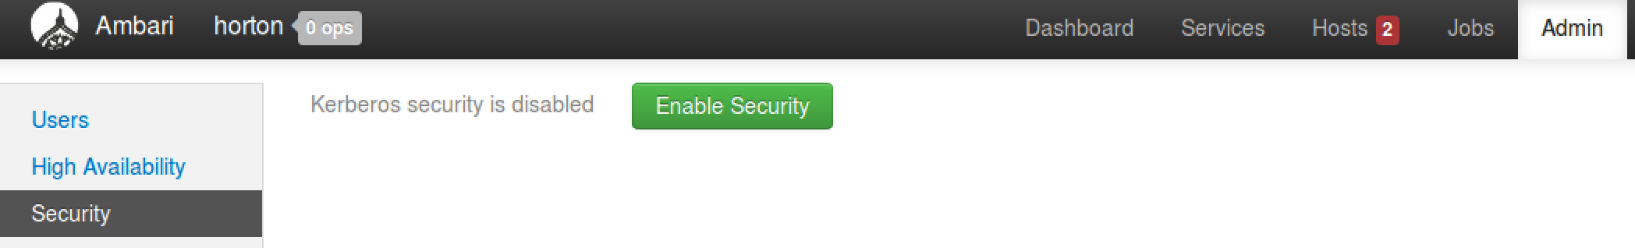
  - Click the Enable Security button.
  - Notice on the Get Started step of the Enable Security Wizard there are four manual steps that must be completed first. We have already executed the first 2 steps. For the remaining 2 steps, click the Next button.
  - The default settings on the Configure Services step of the wizard are fine, so click Next to continue.
- Create the Principals and Keytabs
  - On the Create Principals and Keytabs step of the wizard, all the required default settings for Kerberos are shown in a tabular format. Click the Download CSV button at the bottom of the page and save the file:
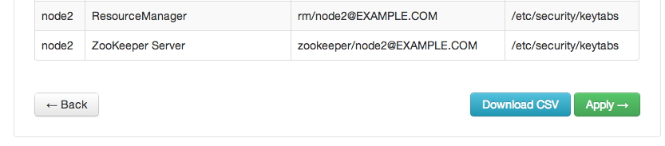
  - Exit from hadoop-slave1, so that you will be no more on any node. The command prompt should show root@ubutnu:
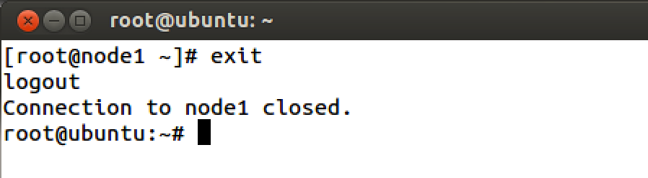
  - Execute following command to copy CSV file to hadoop-slave1 (type this command in one line):
# scp Downloads/host-principal-keytab-list.csv hadoop-slave1:scripts/kerberos.csv
Now login back to hadoop-slave1 and navigate to /root/scripts folder. You must see kerberos.csv file there.
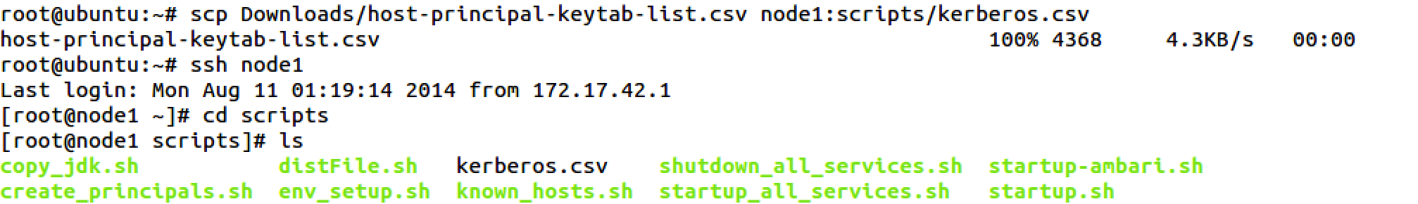
  - Run the pre-written script to create all required principals and keytabs. It will ask for the location of the CSV file you created. Provide the full path (/root/scripts/Kerberos.csv) to the file:
# /root/scripts/create_principals.sh
NOTE: This step will create all required principals and keytab files on all the nodes. Once you are done with the step, go back to Ambari UI.
- Finish the Enable Security Wizard
  - We have completed all 4 required steps. Now it is time to enable security through Ambari. Click the Apply button.
  - The Save and Apply Configuration step can take 5-10 minutes. When the task is complete, click the Done button:
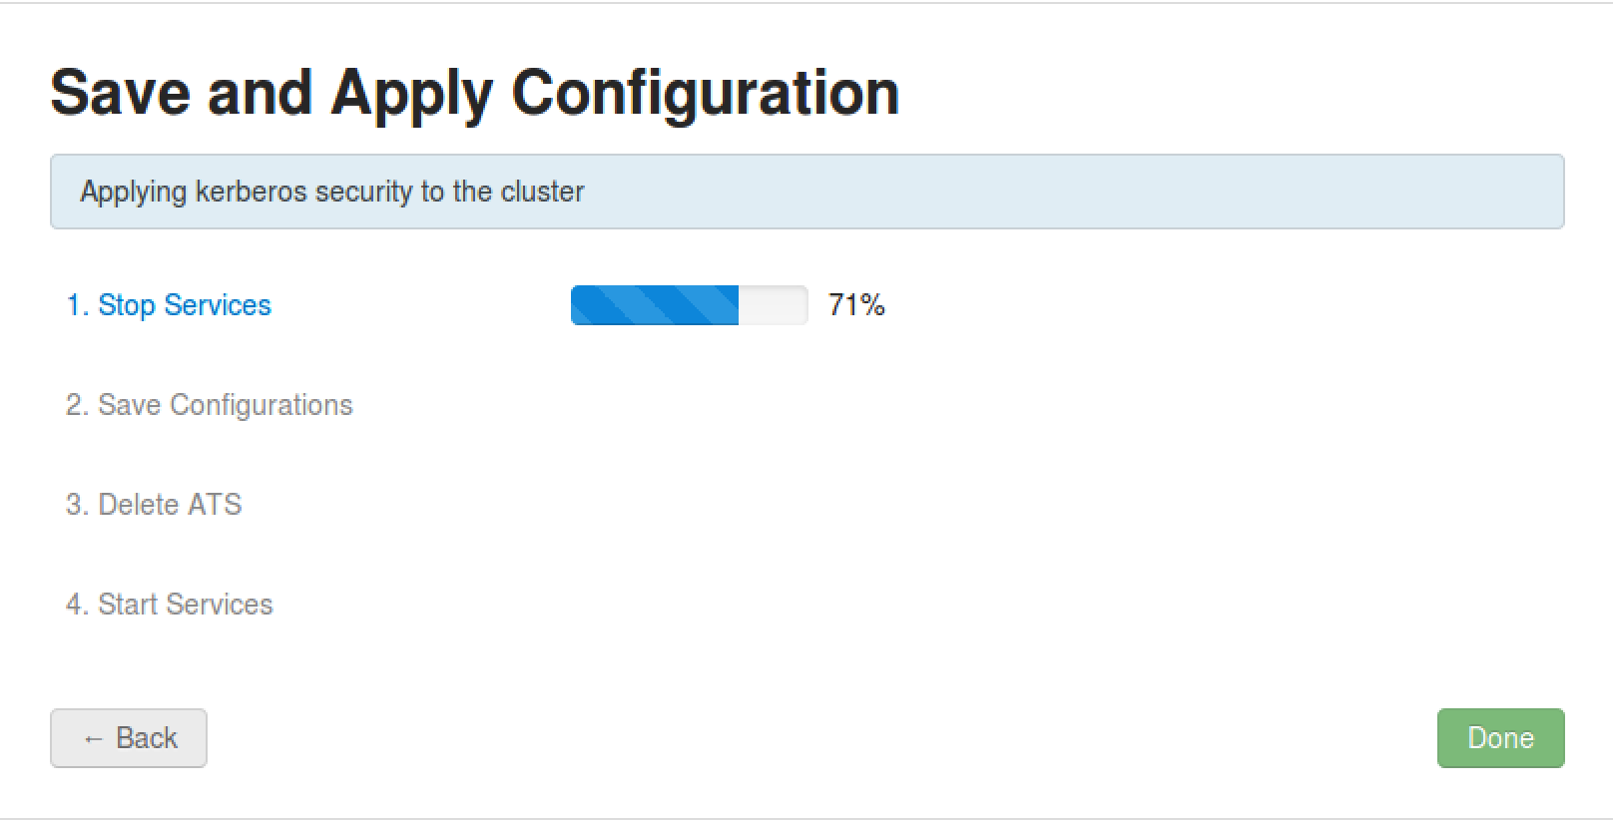
- Verify Security is Enabled
  - On hadoop-slave1, switch to the hadoop user and try to list the contents of /user in HDFS:
# su - hadoop
$ hadoop fs -ls /user
The command should throw an error.
- Configure User Permissions
  - Logout from ‘hadoop’ user.
  - As the root user, add hadoop to the Kerberos database. Start the kadmin service by typing following:
# kadmin.local
  - Type following command to create a hadoop principal:
kadmin.local: addprinc -randkey hadoop@EXAMPLE.COM
  - Now create a keytab file in the /etc/security/keytabs directory using the following command:
kadmin.local: xst -norandkey -k /etc/security/keytabs/hadoop.headless.keytab hadoop@EXAMPLE.COM

kadmin.local: exit
  - Set appropriate permissions for the keytab file for the hadoop user:
# chown hadoop:hadoop /etc/security/keytabs/hadoop.headless.keytab

# chmod 440 /etc/security/keytabs/hadoop.headless.keytab
  - Switch to the hadoop user and initialize the keytab file:
# su - hadoop
$ kinit -kt /etc/security/keytabs/hadoop.headless.keytab hadoop@EXAMPLE.COM
  - Now try to list the contents of /user in HDFS again. This time you should be able to view the folder’s contents!

RESULT: You have enabled Kerberos security for your HDP cluster.

